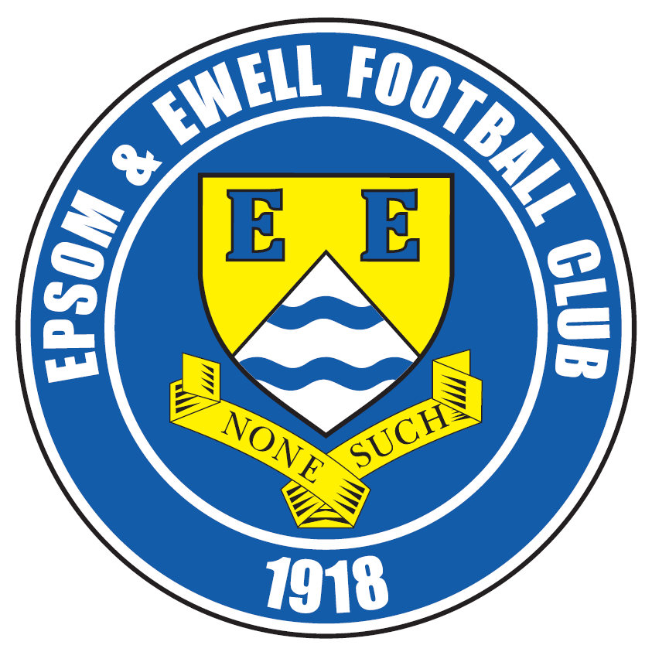 | Epsom & Ewell F.C.  20  v  Hartley Wintney  Tuesday, 23rd February 2016 – 7.45 p.m.
Good evening! We welcome the players, supporters and officials of Hartley Wintney for a League match, together with today’s match officials and our own regular supporters.

We must firstly apologise for the reduced programme this evening. The reasons for this are explained within our Club Statement on page 3.

Our opponents have had a fantastic season so far, with good runs in both the F.A. Cup and the F.A. Vase, and are currently favourites for the League title as well. We met over there in November on a very windy Tuesday evening and a late Tom Neale goal enabled us to complete a 3-3 draw after behind 3-1 behind on the hour.

On the night we felt we were unfortunate to be behind in the first place, having played really well in the first half, only to turn around at 1-1, mainly due to some excellent saves from their keeper. However, to go behind to a penalty and own goal was really harsh and although we left it late, a point was the least we deserved.

Richard recently referred in a match report to the fact that we had now played the other four best sides in the league all away from home, avoiding defeat in every case, although we still have all four to come here, starting tonight and continuing on Saturday when Horley Town visit us. However, whilst draws at tough places like Camberley, Hartley and Horley may well be good results, we know that if we are to make a final push for the title, we need to win our home games and this is our target tonight.

We were last in action here against Bedfont Sports ten days ago, when a Tom Neale goal was the difference between the teams in our 1-0 win.

Three days later we suffered another postponement at AFC Hayes. This was the third time this match has been postponed. We then had no game on Saturday.

Following the Horley match we are back here once again next Tuesday when Spelthorne Sports visit. After this we travel to Chertsey Town on Saturday week before returning here for matches with Knaphill and Cove in quick succession. There are many games to catch up before the season ends, so please keep in touch with the website which will contain as much information as we are able to supply under the circumstances.

The Programme Team

Keep up with us on Facebook www.facebook.com/epsomandewellfc and on Twitter @EEFCOfficial

Cover Photos by Gemma Jarman

- Rob Hendry scores our equaliser at Camberley two weeks ago

- Kyle Hough scores the winner against tonight’s visitors in last season’s 2-1 win


Cherry Red Records Combined Counties League
Premier Division Table 2015/16
inc Saturday 20th February | P | W | D | L | F | A | Pts | GD | H | A
Hartley Wintney | 26 | 22 | 2 | 2 | 81 | 23 | 68 | +58 | 23/2 | 3-3
Ashford Town (Mx) | 29 | 21 | 2 | 6 | 78 | 38 | 65 | +40 | 30/4 | 3-2
Epsom & Ewell | 26 | 16 | 8 | 2 | 60 | 23 | 56 | +37 | X | X
Camberley Town | 25 | 17 | 5 | 3 | 50 | 21 | 56 | +29 | 16/4 | 1-1
Hanworth Villa | 27 | 15 | 3 | 9 | 52 | 38 | 48 | +14 | 5-0 | 23/4
Horley Town | 26 | 14 | 5 | 7 | 63 | 35 | 47 | +28 | 27/2 | 2-2
Colliers Wood United | 32 | 14 | 4 | 14 | 64 | 56 | 46 | +8 | 3-1 | 3-0
Spelthorne Sports | 28 | 11 | 7 | 10 | 50 | 53 | 40 | -3 | 1/3 | 6-2
Raynes Park Vale | 27 | 12 | 2 | 13 | 53 | 53 | 38 | 0 | 3-1 | 28/3
Windsor | 28 | 10 | 8 | 10 | 50 | 54 | 38 | -4 | 2-2 | 1-2
Guildford City | 29 | 10 | 6 | 13 | 55 | 64 | 36 | -9 | 4-0 | 2/4
Knaphill | 22 | 11 | 2 | 9 | 46 | 35 | 35 | +11 | 12/3 | 1-1
Sutton Common Rovers | 27 | 10 | 3 | 14 | 48 | 56 | 33 | -8 | 3-1 | 2-1
AFC Hayes | 29 | 9 | 6 | 14 | 41 | 55 | 33 | -14 | 1-1 | 12/4
Farnham Town | 23 | 9 | 4 | 10 | 42 | 36 | 31 | +6 | 1-0 | 22/3
Badshot Lea | 26 | 10 | 1 | 15 | 40 | 69 | 31 | -29 | 9/4 | 1-0
Bedfont Sports | 27 | 7 | 8 | 12 | 35 | 39 | 29 | -4 | 1-0 | 2-2
Chertsey Town | 28 | 8 | 5 | 15 | 39 | 51 | 29 | -12 | 0-1 | 5/3
Westfield | 21 | 7 | 6 | 8 | 26 | 34 | 27 | -8 | 26/3 | 0-0
Chessington & Hook | 26 | 7 | 2 | 17 | 42 | 67 | 23 | -25 | 1-0 | 19/3
Redhill | 22 | 3 | 3 | 16 | 27 | 56 | 12 | -29 | 3-0 | 1-0
Cove | 25 | 1 | 0 | 24 | 15 | 99 | 3 | -84 | 15/3 | 7-0

Lucky Day? – 23rd February
Played 15 - W 6 D 2 L 7 - F 26 A 30 - PPG 1.33 - Average
Our Club record against today’s visitors
Played 9 - W 4 D 3 L 2 - F 25 A 16 - PPG 1.60 - Above Average
Largest wins and losses against today’s visitors
11th October 2008 - (H) W 5-0 - League - 9th March 2013 - (H) L 2-4 - League
Their Last visit
Saturday 21st February 2015 - W 2-1 - Combined Counties League

Club Statement – 14.02.16


Please note that our Club Media Officer, Richard Lambert has been fined and forced to serve a 28 day administration ban by the Surrey F.A. for a critical comment that he made on his personal Twitter account.

Epsom and Ewell FC do not agree with the charge, the penalty, or the fact that anyone should be penalised for their private remarks as long as they do not break the law of the land. Our club suffers too, because regrettably we are forced to abide by their decision.

Many thousands of us could all be affected by this ruling, and it appears that Richard has been picked on because of his close allegiance with our club. He has considered walking away entirely, but he assures us that he will return once this matter is concluded and has taken some time off.

In the meantime he has provided us with all the information we require to enable us to operate the Twitter account, the match programme and the website and we will attempt to replicate his efforts here to the best of our ability, although obviously the service will be much reduced. We hope you understand and will bear with us during this time.

Epsom and Ewell FC will be making no further comment on this matter.

Latest Results and Fixtures
Combined Counties League – Saturday 13th February
Ashford Town (Mx) | 0-1 | Westfield
Epsom & Ewell | 1-0 | Bedfont Sports
Guildford City | 1-1 | AFC Hayes
Spelthorne Sports | 2-1 | Raynes Park Vale
Windsor | 3-2 | Redhill
Combined Counties League Cup – Tuesday 16th February
Cobham | 3-0 | Frimley Green
Knaphill | 2-1 | Chertsey Town
Raynes Park Vale | 0-2 | Westfield
Redhill | 0-2 | Farnham Town
Combined Counties League – Tuesday 16th February
AFC Hayes | p-p | Epsom & Ewell
Camberley Town | 1-1 | Spelthorne Sports
Chessington & Hook United | p-p | Sutton Common Rovers
Cove | 2-6 | Badshot Lea
Hanworth Villa | 1-3 | Guildford City
Hartley Wintney | 2-0 | Bedfont Sports
F.A. Vase – Quarter - Final – Saturday 20th February
Hereford FC | 3-2+ | Camberley Town
Combined Counties League – Saturday 20th February
AFC Hayes | 3-1 | Windsor
Ashford Town (Mx) | 3-1 | Cove
Chertsey Town | 3-4 | Badshot Lea
Chessington & Hook United | p-p | Westfield
Colliers Wood United | 2-4 | Guildford City
Horley Town | 4-0 | Spelthorne Sports
Knaphill | p-p | Farnham Town
Raynes Park Vale | p-p | Bedfont Sports
Redhill | p-p | Hanworth Villa
Sutton Common Rovers | 0-5 | Hartley Wintney
Combined Counties League – Tuesday 23rd February
Badshot Lea | V | Westfield
Cove | V | Spelthorne Sports
Epsom & Ewell | V | Hartley Wintney
Farnham Town | V | Camberley Town
Redhill | V | Chessington & Hook United
Combined Counties League – Saturday 27th February
AFC Hayes | V | Windsor
Latest Results and Fixtures
Combined Counties League – Saturday 27th February
Cove | V | Spelthorne Sports
Epsom & Ewell | V | Horley Town
Farnham Town | V | Camberley Town
Ashford Town (Mx) | V | Cove
Chertsey Town | V | Badshot Lea
Chessington & Hook United | V | Westfield
Colliers Wood United | V | Guildford City
Horley Town | V | Spelthorne Sports
Knaphill | V | Farnham Town
Raynes Park Vale | V | Bedfont Sports

Player Profile – Number 13 – Glyn Mandeville
Our latest profile is from the man in charge, who now has a chance to get his own back!

Age: 40

Position: Manager

Club supported: Liverpool

Best Moment Managing: Taking on the job at Epsom & Ewell

Best Moment Playing: Signing for Fulham and playing at Wembley

Favourite Food: Steak and Chips with peppercorn sauce

Messi or Ronaldo: Messi

Favourite Drink: Fosters

Fastest Player at the Club: Reisse Griffin or Tom Neale

Slowest Player at the Club: Michael Eacott or Rhys North

Joker at the Club: All make me laugh

Best Trainer at the Club: Reisse Griffin

Favourite Ground played at: Wembley Stadium


Best Dressed Player at club: All pretty smart lads on a night out to be honest

Worst Dressed Player at club: Scuba with his hat!

Last Person You would expect to buy you a beer at the bar: The referee!

Describe the Gaffa in three words: Bloody – Good – Bloke!

Hartley Wintney - History
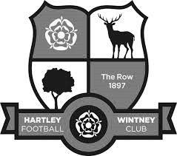
Hartley Wintney Football Club, as our records indicate, was founded in 1897 and played in an area situated at Causeway Farm, not far from our present headquarters and adjacent to the village's golf and cricket clubs. From stories told by the older members, and from the old club records, it appears that the village side competed well against local opposition, despite the facilities not being of today's standard, with only a horse trough or the pond to remove the heavy mud from a sub-standard pitch. In 1953, the club moved to its present ground in Green Lane, known as 'The Memorial Ground'. A pavilion was erected and the team played in the Basingstoke and Aldershot Leagues.

In 1973, Glynn Howells (a former Epsom & Ewell goalkeeper and father of Tottenham player David Howells) was appointed Manager and, with an influx of players, Hartley Wintney FC was put firmly on the local football map. In his six year reign, the team managed to win the Aldershot Senior League three times in succession and, on a night to remember, the Aldershot Senior Cup. In 1975, the facilities were once again improved, when a bar was built within the pavilion.

After several seasons in the ASL, Hartley applied for the Combined Counties League - a competition that replaced the Surrey Senior League - and were granted admittance. After the first couple of seasons and two changes of management, the club appointed Ian Bedford as Manager. Once again an influx of senior players gave Hartley the success they deserved. Within his three years in management, they gained trophies including the League Title (1982-1983) and Runners Up (1981-1982), Aldershot Senior Cup Winners (1980-1981), George Allen Cup Winners (1981-1982). They were also Runners Up in the League Cup (1982-1983) and Aldershot Senior Cup (1981-1982).

During this period a new Club House, which is our present H.Q., was opened by ex-Chelsea star Peter Osgood. These facilities, together with the recently improved dressing rooms, are ranked as amongst the very best in the League. David Willoughby, the then Secretary/Treasurer, and Bill Mitchell, Chairman, spent exceptional hours in the embryo stages of this venture - one of the bars is now named 'The David Willoughby Room'.

Hartley Wintney FC has come a long way, from village side in every sense of the term, to today's 7 days a week modern Football Club, but it’s hard working committee has succeeded in retaining a village atmosphere. In recent years, the club has invested in new floodlights costing £40,000, completely rebuilt the changing rooms at a cost of over £100,000, and erected a modern stand with seating. The Club is indebted to the volunteer workers who continue to keep the Club afloat.

The club gained promotion from Division One of the Combined Counties League in 2007-08. But 08/09 began poorly and ended in relegation by a narrow margin. The 2011-12 season under manager Neville Roach, Assistant Mick Wollen and Coach Scott Tarr was a notable one for the club as they again achieved promotion back to the Combined Counties League Premier Division and also had a fine F.A. Cup run that took them to the third qualifying round, going out in the Third Qualifying Round at Conference South near neighbours Basingstoke Town.

The euphoria of the cup run and promotion was dampened at the end of the 2011-12 season when the coaching staff left to take the managerial role at Southern League Thatcham Town. The entire squad bar two players left, and so new manager Dave Tuttle was faced with the huge task of rebuilding a squad competitive enough for the CCL Premier. A reasonably good squad was assembled, but events behind the scenes and within the playing squad added to the pressure following a string of poor results. It led to a second change in the management setup of the first team in less than 4 months, with 24 year-old Ben Dillon given his first managerial position.

Jason Minton became Ben's Assistant, with Joe Lawler also joining as coach, and once again there was an almost total outflow of the players Dave Tuttle had brought to the club. Ben and Jason thus had to set about again rebuilding the squad, but by this time with Hartley well and truly set adrift at the bottom of the league and the season in full flow. Clearly something of a baptism of fire for the young managerial partnership, but their enthusiasm, belief and the introduction of a talented group of new players quickly restored the spirit around the whole club. Hartley Wintney's place in the CCL Premier was secured after a truly remarkable second half of the season thanks to the belief and commitment of the new squad and the coaching staff and in 2013/14 they reached the F.A. Cup fourth qualifying round, losing at home to Southern League Daventry Town.

The football club has established a clear line of progression for young players with the establishment of an U18 Youth setup playing in the Southern Youth League, and a Reserve team playing in the Suburban League. The senior club has also moved to improve links with the Junior club. These factors are huge positives which the committee hopes will greatly improve the club's chances of continuing to play and maintain their position at an elevated level of amateur football.

From behind the goal
Epsom & Ewell 1-0 Bedfont Sports
Combined Counties League – Premier Division – Saturday 13th February 2016

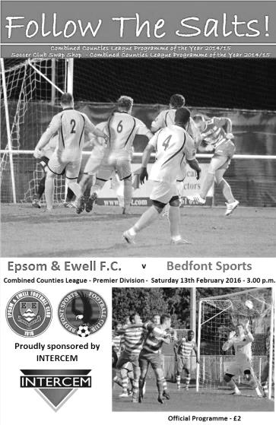
Salts win close encounter

Epsom and Ewell hosted Bedfont Sports on Saturday needing a win to keep up with the other leading teams and succeeded, thanks to a defensive error in the 14th minute as Tom Neale beat the keeper to a weak back pass, rounded him and knocked the ball into an empty net.

We started well but after the goal found ourselves doing a bit too much defending and survived a concerted penalty shout as a right wing cross was headed towards goal but appeared to be blocked by the arm of one of our defenders and out for a corner.

The second half was more even and Epsom found themselves a man up after 58 minutes when Tim Pitt kicked out at Matt Ferdinando, leading to a large scuffle with many players involved.

Despite the advantage Epsom struggled to create many clear cut chances and Adrian Jones, in goal for the injured Michael Eacott, made a smart low save in added time of which there was eight minutes played. However, we held on to claim the points and travel to AFC Hayes on Tuesday in good spirits.

Team: Adrian Jones, Rhys North, Alex McKay, Dan Dean, Craig Hastings, Bentley Graham, Matt Tanton, Matt Farrell (c), Tom Neale, Matt Ferdinando, Reisse Griffin

Subs: Savvas 'Agi' Panayiotou for McKay (70), Elliott Thompson for Griffin (78), James Taylor for Dean (84)

Centre page for results

Centre page for results



Player Sponsorship
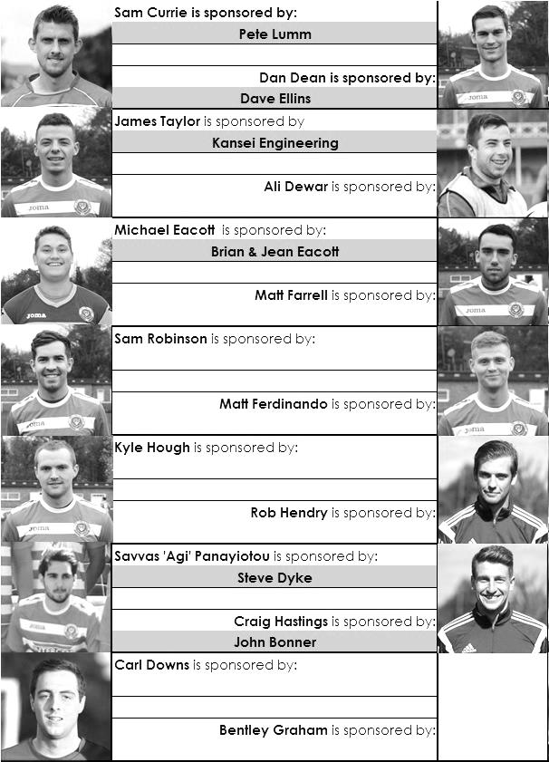

Here is the current list for the 2015/16 season showing all of our players and Management that are currently available for sponsorship this season.

Sponsorship costs just £40 and it is easy to do. Just select a player who has not been previously sponsored and let a Committee Member know that you would like to sponsor them. Beware though. Until we have received the money it is possible for someone to jump in front of you, so don’t delay, sponsor today!

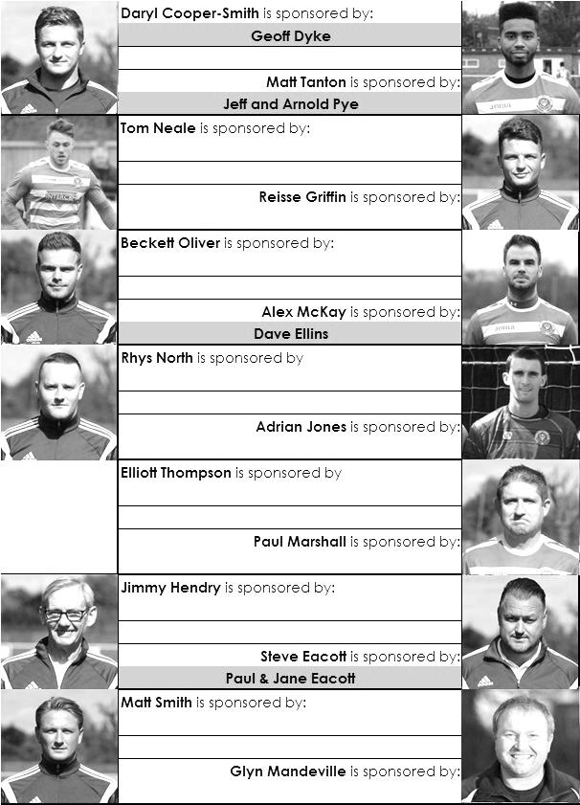

CCL Premier Division Club Directory
A.F.C. HAYES Telephone: 0208-845-0110 - Ground: Farm Park, Kingshill Avenue, Hayes, Middx. UB4 8DD - Colours: Blue and White Stripes/Blue/Blue

ASHFORD TOWN (Mx) Telephone: 01784-245908 - Ground: The Robert Parker Stadium, Short Lane, Stanwell, Middx. TW19 7BH - Colours: Tangerine & White Stripes/Black/Tangerine

BADSHOT LEA Telephone: 01252-320385 - Ground: Ash United FC, Shawfield Stadium, Youngs Drive, Shawfields Road, Ash, Hampshire. GU12 6RE - Colours: Claret/White/Claret

BEDFONT SPORTS Telephone: 0208-831-9067 - Ground: Bedfont Sports Club, Hatton Road, Bedfont, Middx TW14 8JA - Colours: Red & Black Hoops/Black/Red & Black Hoops

CAMBERLEY TOWN Telephone: 01276-65392 - Ground: Krooner Park, Wilton Road, Camberley, Surrey. GU15 2QW - Colours: Red & White Stripes/Blue/Red

CHERTSEY TOWN Telephone: 01932-561774 - Ground: Alwyns Lane, Chertsey, Surrey. KT16 9DW - Colours: Royal Blue & White Stripes/Royal Blue/Royal Blue

CHESSINGTON & HOOK UNITED Telephone: 01372-602263 - Ground: Chalky Lane, Chessington, Surrey. KT9 2NF - Colours: Blue/Blue/Blue

COLLIERS WOOD UNITED Telephone: 0208-942 8062 - Ground: Wibbandune Sports Ground, Robin Hood Way, Wimbledon. SW20 0AA - Colours: Blue & Black Stripes/Black/Black

COVE Telephone: 01252-543615 - Ground: Oak Farm Fields, 7 Squirrel Lane, Cove, Farnborough, Hampshire. GU14 8PB - Colours: Yellow/Black/Yellow

EPSOM & EWELL Telephone: 01737-553250 - Ground: Chipstead FC, High Road, Chipstead, Surrey. CR5 3SF - Colours: Royal Blue & White Hoops/Royal Blue/Royal Blue & White Hoops

FARNHAM TOWN Telephone: 01252-715305 Ground: Memorial Ground, Babbs Mead, West Street, Farnham, Surrey. GU9 7DY Colours: - Claret & Sky Blue /White/ Claret & Sky Blue

GUILDFORD CITY Telephone: 01483-443322 - Ground: The Spectrum, Parkway, Guildford, Surrey. GU1 1UP - Colours: Red & White Stripes/Black/Black

HANWORTH VILLA Telephone: 0208-831-9391 - Ground: Rectory Meadows, Park Road, off Hounslow Road, Hanworth, Middlesex. TW13 6PN - Colours: Red & White Stripes/Black/Black

HARTLEY WINTNEY Telephone: 01252-843586 - Ground: Memorial Playing Fields, Green Lane, Hartley Wintney, Hants RG27 8DL - Colours: Orange & Black/ Orange /Orange

HORLEY TOWN Telephone: 01293-822000 - Ground: The New Defence, Anderson Way, Court Lodge Road, Horley, Surrey. RH6 8SP - Colours: Claret & Sky Blue/Claret/Claret

KNAPHILL Telephone: 01483-475150 - Ground: Brookwood Country Park, Redding Way, Lower Guildford Road, Knaphill, Surrey. GU21 2AY - Colours: Red/Black/Red

SUTTON COMMON ROVERS Telephone: 01932-866386 - Ground: Sutton United FC, Gander Green Lane, Sutton, Surrey SM1 2EY - Colours: Yellow/Black/Black

RAYNES PARK VALE Telephone: 020-8540-8843 - Ground: Prince Georges Playing Field, Grand Drive, Raynes Park, London. SW20 9NB - Colours: Blue/Blue/Red

REDHILL Telephone: 01737-762129 - Ground: Kiln Brow, Three Arch Road, Redhill, Surrey RH1 5AG - Colours: Red and White Stripes/Black/Red

SPELTHORNE SPORTS Telephone: 01932-961055 - Ground: Spelthorne Sports Club, 296 Staines Road, Ashford Common, Ashford, Middx. TW15 1RY - Colours: Light & Dark Blue/Dark Blue/Light Blue

WESTFIELD Telephone: 01483-771106 - Ground: Woking Park, Kingfield Road, Woking, Surrey. GU22 9BA - Colours: Yellow/Black/Black

WINDSOR Telephone: 01753-860656 - Ground: Stag Meadow, St Leonards Road, Windsor, Berks SL4 3DR - Colours: Red/Red/Red

Match and Ball Sponsorships – 2015/16
Opponent | Date | Match Sponsor | Match Ball Sponsor
Hoddesdon Town | 18/07/15 | Geoff Dyke
Windsor | 08/08/15 | Club President - Stella Lamont
Erith & Belvedere (FAC) | 16/08/15 | Committee Member - Mike Lovett
Raynes Park Vale | 31/08/15 | EEFC Management Committee
Colliers Wood United | 08/09/15 | Bookham Building Shop – www.buildingshop.co.uk
AFC Hayes | 19/09/15 | John Bonner
Farnham Town | 26/09/15 | Ezara and Inaya Beddoe – our youngest supporters!
Chertsey Town | 17/10/15 | Club Media Officer – Richard Lambert
Dorking Wanderers (SSC) | 20/10/15 | Tony Ferdinando
Chessington & Hook United | 07/11/15 | Paul Merritt
Hanworth Villa | 21/11/15 | Maggie Beddoe
Guildford City | 05/12/15 | Pete Lumm
Sutton Common Rovers | 19/12/15 | Marvin Hough
Ashford Town (Mx) (LC) | 12/01/16 | Pete Beddoe & Steve Dyke
Redhill | 02/02/16 | David Lawton
Bedfont Sports | 13/02/16 | Bookham Building Shop – www.buildingshop.co.uk
Hartley Wintney | 23/02/16
Horley Town | 27/02/16
Spelthorne Sports | 01/03/16 | In memory of Chris Henry
Knaphill | 12/03/16
Cove | 15/03/16
Westfield | 26/03/16 | Nathan Lambert
Badshot Lea | 09/04/16
Camberley Town | 16/04/16
Ashford Town (Mx) | 30/04/16 | Club President - Stella Lamont
Ashford Town (Mx) | 30/04/16 | Brian Eacott | Steve Dyke
For League, League Cup and Surrey Senior Cup Matches:
Match sponsorship - £40.00 Match ball sponsorship - £25.00. Combined £55.00.
For F.A. Cup and F.A. Vase matches:
Match sponsorship - £50.00 Match ball sponsorship - £30.00. Combined £65.00.

Sponsorship includes: ( x2 for match, x3 for match and ball )

Admission, programmes, hospitality, advertising and mascot for the day (if required ).
If you are interested, just speak to a Committee Member, or drop me an email at: richard.c.lambert@gmail.com


We also thank our Kit Sponsors INTERCEM

Combined Counties League – Premier Division
Tuesday, 23rd February 2016 - Kick-off 7.45 p.m.
Epsom and Ewell  (Royal Blue & White hoops) | V |  | Hartley Wintney  (All Orange)
Squad | NUMBERS |  | Squad
Michael Eacott |  |  | Craig Atkinson
Rhys North |  |  | Tom Walsh
Alex McKay |  |  | Callum Eagle
Craig Hastings |  |  | Aaron Parfitt
Dan Dean |  |  | Steve Noakes
Bentley Graham |  |  | Liam Eagle
Matt Tanton |  |  | Ian Jones
© Matt Farrell |  |  | Sam Argent
Tom Neale |  |  | Ross Cook
Matt Ferdinando |  |  | Steve Duff
Reisse Griffin |  |  | Dean Stow
Sam Robinson |  |  | Joe Paris
Beckett Oliver |  |  | Zac Horkan
Kyle Hough |  |  | James King
Rob Hendry |  |  | Jake Maddock
Savvas ‘Agi’ Panayiotou
Adrian Jones
Sam Currie
Elliott Thompson
Carl Downs
James Taylor
Glyn Mandeville | MANAGER |  | Anthony Millerick
Matt Smith | ASSISTANT
Steve Eacott / Alex McKay / Jimmy Hendry | COACHES / PHYSIO
REFEREE: N.Owen (Kingston)
ASSISTANTS: W.Ingram (New Malden), K.Corrick (Oxted)

OUR NEXT VISITORS TO HIGH ROAD ARE:
Horley Town

Saturday 27th February 2016 - Kick-off 3.00 p.m.
Combined Counties League – Premier Division

